WAD Ruby + Sinatra Assignment 1

Stefan Rudvin 51549217

This is a wiki web application for tourist destinations in Scotland. It has an editable article that has information about the Dunnottar Castle in Stonehaven, Isle of Skye, Cairngorms National Wildlife Park and Glen Coe. The Wikipedia has multiple features listed below.

# **Overview**

**Features:**

* An article that can be edited by users with editing rights
* Word & Character Count
* Login page
* Account creation
* Send feedback to administrator
* Designed with CSS
* Custom font through Google’s font repositories
* Page visit counter

**Administrator features:**

* View log files (updated every time wiki is edited)
* Archive (Backup, View)
* Reset article
* Create, edit and delete users
* View feedback from users

To run this application, extract the .zip file and copy the ‘wiki’ folder into your preferred ruby on rails IDE which supports Sinatra (Cloud9 IDE and Chrome browser are recommended). Install the following gems if you do not have them installed yet: Sinatra, haml rspec, data_mapper, sqlite3, dm-sqlite-adapter.

Navigate to the ‘/wiki’ folder and start the application with the command:

ruby wiki.rb -p $PORT -o $IP

Click on the link that appears to begin.

Appendices at the end of the report show screenshots of code and the website.

# **Features**

**Editable page**

I created an editable page by writing text onto a .txt file that can be changed and opened anywhere within the application. This text file is manipulated when the article is edited and simultaneously copied to a log file.

**Character and Word count**

The characters were counted using the len.to_s and the word count was found with the .split.size function. These could then be displayed at the bottom of the article.

**Page visit counter**

I create a visit counter by creating a counter.txt file which appends a single letter ‘h’ every time the home page is called. The home page then displays the number of characters in the file, effectively showing how many times it has been visited.

**Administrator Features**

**a. Override changes to the details made by a user**

The administrator has the power to remove edit privileges from any user and edit the articles him/herself. He can also reset or look at the archives to find information that has been changed.

**b. Archive the details to a separate text file**

I created a separate archive txt. File to which I could send a copy of the wiki at any time. I used the append method so that previous entries in the archives would not be overwritten.

**c. Add/edit/delete additional users and change their access privileges to edit details**

These functions were created using the credentials method, were only the administrator can enter the admincontrols section where changes to users can be made. The administrator can change the edit privileges of users or delete them altogether. However, guests can create accounts for themselves but they won’t get edit priviledges.

**d. Enable the wiki to be reset by the administrator to its initial default details**

To make this, I have a backup for the wiki article available so the reset function essentially removes the current article data and overwrites it with the backup file.

**A link to a sign-in page which allows a user to register to edit the wiki**

I created a page to create a user, but the administrator is required to gain edit rights. This was created using the DataMapper feature where usernames and passwords are handled.

**A log text file which is appended each time the wiki is updated with details of changes made**

For this application I created two log files: One that shows the username and time when the article was changes and another that shows the whole article so changes can be seen. I created separate methods for each, mostly using the file.open and file.puts functions.

**A stylish layout displaying the wiki application**

To create a stylish layout I used CSS with a background image, shadows, padding and margins. I also used the Roboto font from Google’s repositories.

**Contact Administrator**

Lastly I wanted to create a feature where users (or guests) can contact the administrator for queries or wishes to gain edit permissions. These are linked in the administrator controls page.

Appendices

1. **Editable page**

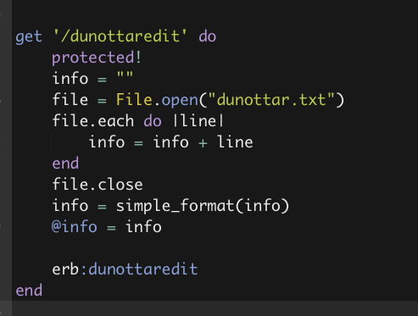

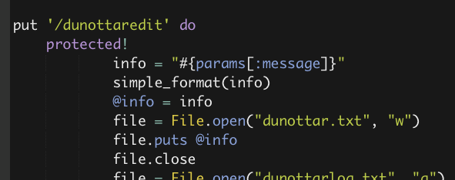

1. **Character and Word count**

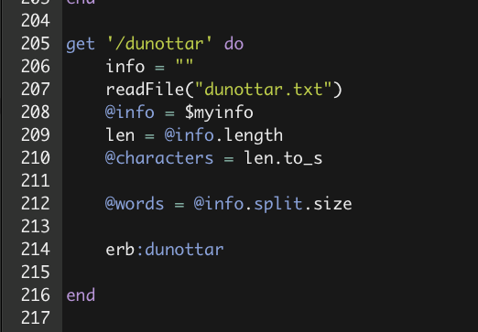

1. **Administrator Features**
2. override changes to the details made by a user

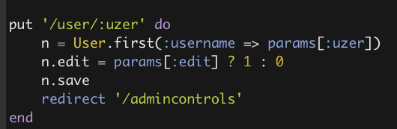

b. archive the details to a separate text file

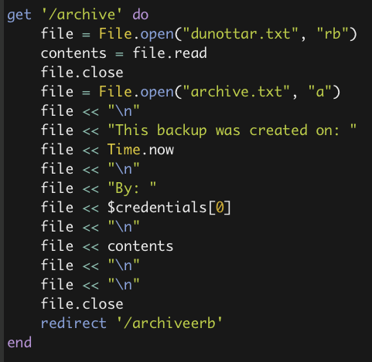

c. add/edit/delete additional users and change their access privileges to edit details

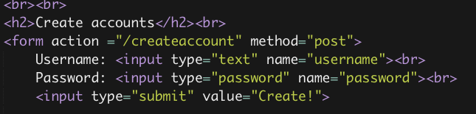

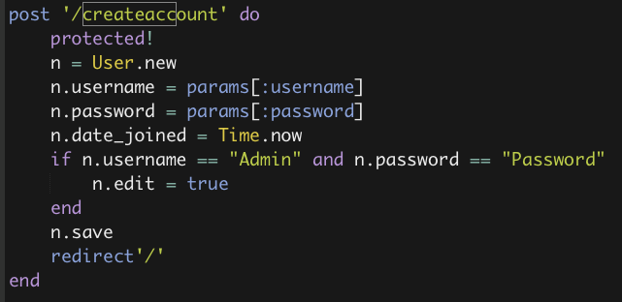

d. enable the wiki to be reset by the administrator to its initial default details. Also code for resetting the log file.

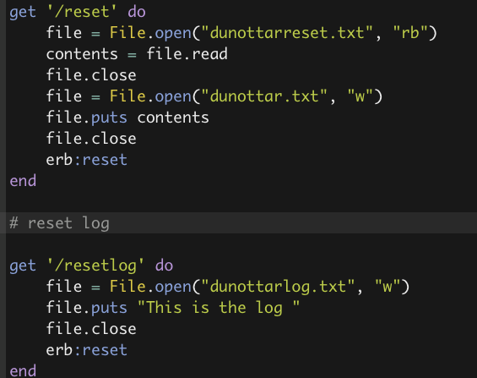

**A link to a sign-in page which allows a user to register to edit the wiki**

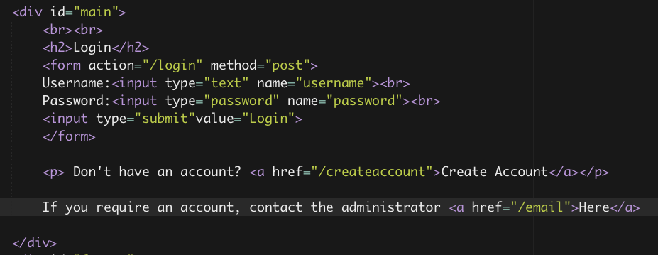

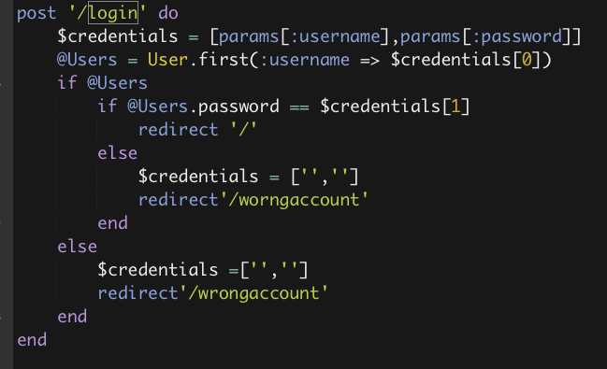

**A log text file which is appended each time the wiki is updated with details of changes made**

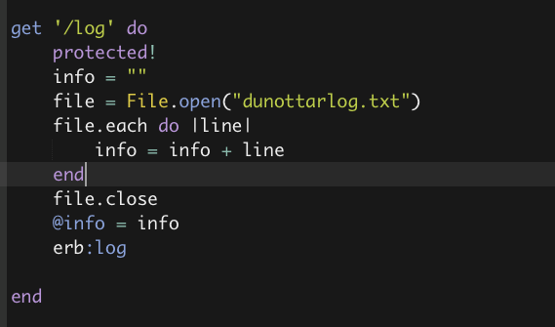

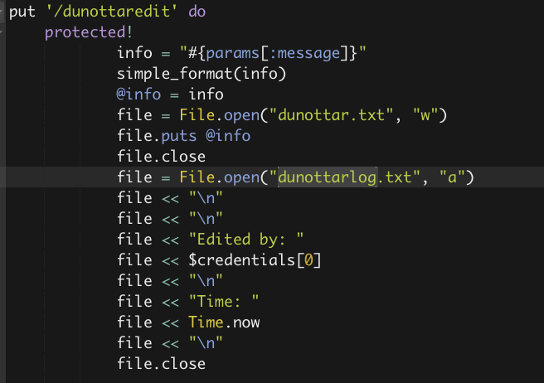

**A stylish layout displaying the wiki application**

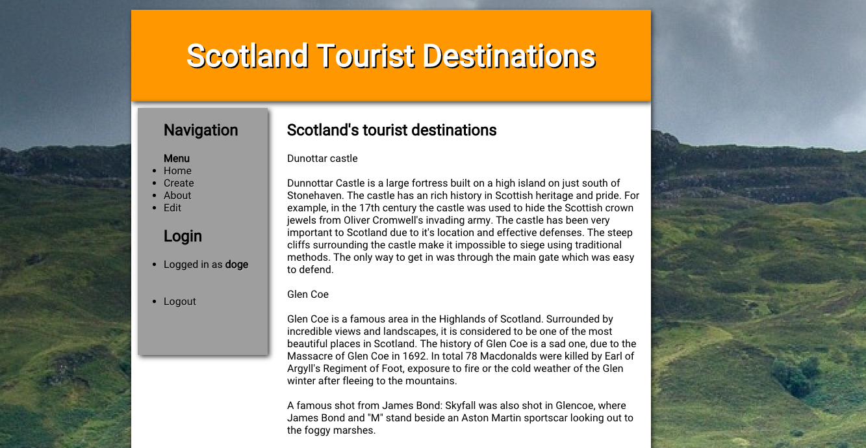

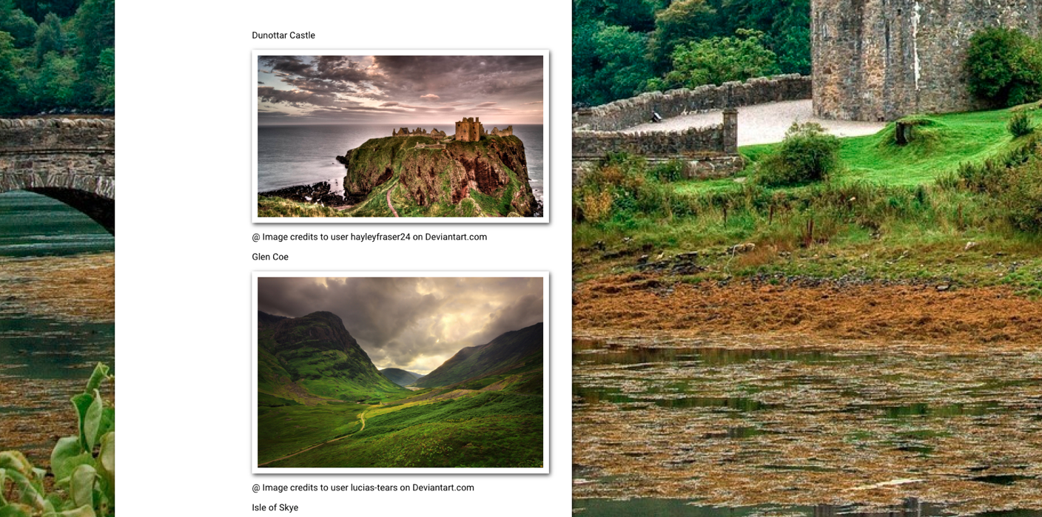

**Contact Administrator**

